

Ain shams University

Faculty of Engineering

Computer and Systems Dep.

**TechFix**

SRS

Introduced by G025

|  |  |  |  |
| --- | --- | --- | --- |
| Version | Written By | Reviewed By | Approved By |
| 0.0 | Group 25 | Dr. Mohamed Sobh |  |
| 1.0 | Group 25 |  |  |

**Table of Contents**

|  |  |
| --- | --- |
| Table of Contents | 2 |
| 1.Introduction | 3 |
| 1.1.Executive Summary | 3 |
| 1.2.Document Overview | 3 |
| 1.3.Abbreviations and Terminologies | 3 |
| 1.4.References | 3 |
| 2.System Description |  |

**1.0 Introduction**

1.1 Executive Summary

TechFix is an online solution offering technicians and services to everyone. TechFix aim to be the leading software in this field. This solution should offer a great number of technicians in all fields. It will facilitate the work of both technicians and landlords. It should offer experienced technicians for different regions in a fast and safe way. TechFix can be used by everyone like landlords, housewives, employers and even technicians themselves. TechFix can be viewed on any computer, mobile or tablet. TechFix contains several functions and modules to offer the best interference and reliability between technicians and customers, also between customers and the website itself. TechFix should be considered as a helpful tool for any crises happening within your area or company. In the very soon future TechFix will prove to be efficient and successful through the feedback of customers and technicians.

1.2 Document Overview

This document introduces TechFix system description and system users. It introduces system modules, system functions, system models, non-functional requirements, domain requirements and system interfaces.

1.3 Abbreviations and Terminologies

HTML: Hypertext markup language.

CSS: Cascading style sheets.

PHP: Personal home page.

MYSQL: My structured query language.

1.4 References

www.wikipedia.org

www.w3Schools.com

www.stackoverflow.com

**2.0 System Description**

2.1 Introduction

If you in a position where you need to hire a technician, but you don’t know exactly how to contact them. TechFix offers a simple and efficient solution to your problems. As TechFix contains the database for plumbers, carpenters, electricians...and many many more technicians to help you fix almost anything at any time. TechFix helps you find the best technician suitable for your problem, by giving you previous feedbacks about him/her from other previous clients. TechFix also informs you about the working hours of that technician, and his/her address if you want to go to the workshop yourself.

2.2 System Architecture

Tech Fix uses a Three-tier architecture. A 3-tier architecture is a type of software architecture which is composed of three “tiers” or “layers” of logical computing. They are often used in applications as a specific type of client-server system. 3-tier architectures provide many benefits for production and development environments by modularizing the user interface, business logic, and data storage layers. Doing so gives greater flexibility to development teams by allowing them to update a specific part of an application independently of the other parts. This added flexibility can improve overall time-to-market and decrease development cycle times by giving development teams the ability to replace or upgrade independent tiers without affecting the other parts of the system. The three layers are

**Presentation Tier:**The presentation tier is the front-end layer in the 3-tier system and consists of the user interface. This user interface is often a graphical one accessible through a web browser or web-based application and which displays content and information useful to an end user. This tier is often built on web technologies such as HTML, JavaScript, CSS, or through other popular web development frameworks, and communicates with other layers through API calls. This tier in TechFix is built on HTML and CSS.

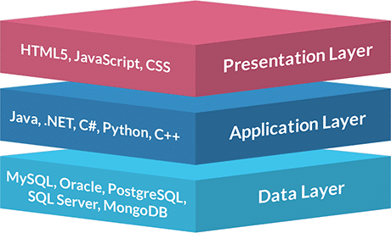**Application Tier:** The application tier contains the functional business logic which drives an application’s core capabilities. It’s often written in Java, .NET, C#, Python, C++,PHP ,etc.  
This layer in TechFix is written in PHP.

**Data Tier**: The data tier comprises of the database/data storage system and data access layer. Examples of such systems are MySQL, Oracle, PostgreSQL, Microsoft SQL Server, MongoDB, etc. Data is accessed by the application layer via API calls. TechFix uses MySQL.

2.3 System modules

TechFix System introduces a huge number of technicians to the users and many services the

contents and services to both desktop users and mobile users via the web. The system consists

of the following modules

1.Client Area

2.Technician Area

3.Registeration

4.Data Storage and Processing

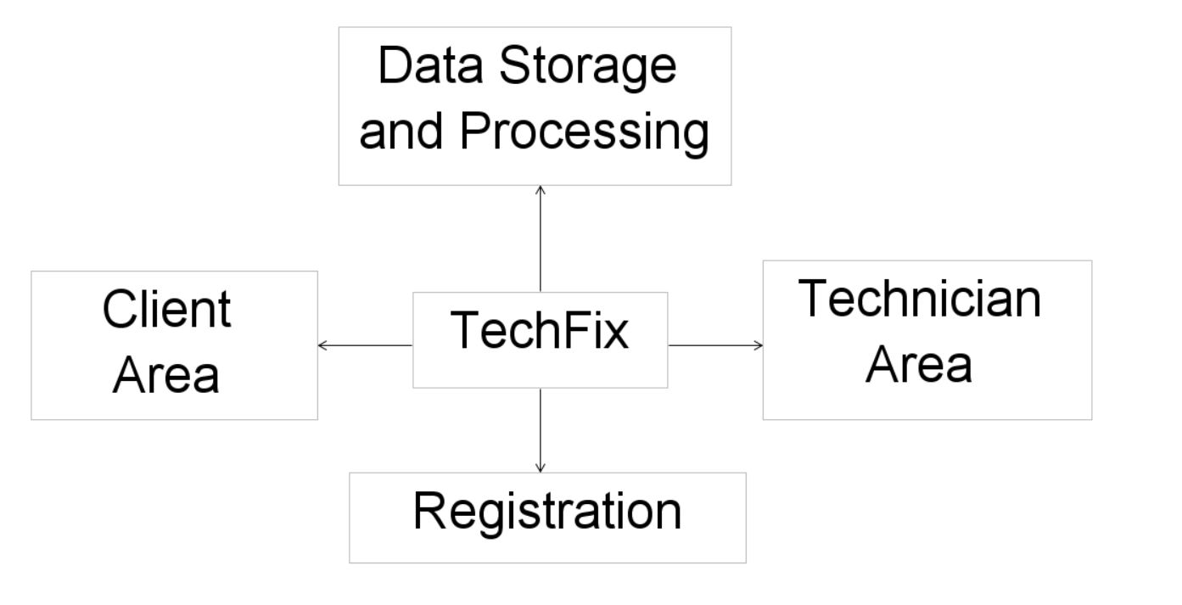

## 2.4 System Users

TechFix Websites has three types of users:

**Client :**The normal user who can enter the site and find the technician he wants and benefit from TechFix Features.

**Technician:**   
The technician makes an account and specify his information so that the technician can to be reached by the users.

**Administrator:**

The admin or the manager for the website, can edit any aspects of the website either by deleting a technician account or adding a new one.

3.0 System Users

3.1 Client

3.1.1 Client Description

Client is anyone who has a problem and wants to find an easier way to find a right technician for his/her problem like someone who need an electrician to fix a specific problem about his/her home’s electrical system or a someone who need a carpenter to repair or make something for him/her.

3.1.2 Client Activities

3.1.2.1 Create Account

The clients can create an account to participate in the site through which he can see the technicians and the type of service they provide and describe their services. The client creates an account by providing

- first name

- last Name

- email

- password

- city and region where they can find technicians closest to their area   
If a client has forgotten his/her password and he/she previously entered an email address when signing up, and you still have access to that email account, then this feature can help him/her to recover his/her access to his/her account. Just choose password reset, where you can enter either your username or your email. The system will send a temporary password to your saved email address that will allow you to retrieve your account. You can change the password after you log in.  
The system provides the clients the ability to change the password. If the client chooses to change his/her password, he/she will then be asked to enter his/her old password to confirm his/her identity, after the identity of the client is confirmed he/she are then asked to enter the new password, then save it. Once the new password is set, the old password is useless and that step of changing the password can’t be undone.

3.1.2.2 Search for Technician

It can be done by many filters such as:

**Search by Name**

Client can search for a specific name directly, without the need for the client to scroll along the whole TechFix database for that specific name.

**Search by Location**

Because sometimes the clients need something to be fixed as fast as possible. Client can search results by location. For the clients to get a technician from the nearby regions to fix his/her problem as quick as possible.

**Search by Category**

Client can choose which service he/she needs and then the search will show only the technicians who provide that service between different types of technicians’ categories including (Carpenters, Plumbers, Electricians, ...etc.).

3.1.2.3 Write Feedback

Client can write his/her feedback about the satisfaction or dissatisfaction they felt with the technician or the service. After a job is done by one of the technicians provided by TechFix, the clients are asked to provide comments, feedbacks and ratings about that technician.

3.1.2.4 Delete Account

Every client in the website will have the ability to deactivate and delete his/her account to which will then be deleted from TechFix databases. But that deletion is permanent and can’t be undone once the client goes through with the process.

3.1 Technician

3.2.1 Technician Description

Technician is including any person who has a certain craft and wants to expand his business online by join TechFix community like:

**Carpenter**

A person who makes and repairs wooden objects and structures.

**Plumber**

A person who installs and repairs the pipes and fittings of water supply, sanitation.

**Electrician**

A person who installs and maintains electrical equipment.

**Mechanic**

A person who repairs and maintains machinery.

**Craftsman**

A person skilled in creating something with a specified material.

3.2.2 Technician Activities

3.2.2.1 Create Account

Technician can create an account in order to participate in the website. Technician can sign up by providing

-First name

-Last Name

-Date of birth

-Country and city

-Email

-Password

-Telephone number

-Fax number (If available)

-Name of business

-Type of service

-Description of his/her provided services

-Workshop address (If available)

-Average working hours and days

3.2.2.2 Add Introduction Video

The technician can provide an introductory video presenting himself/herself, which services are provided and show some of their skills and samples of his/her previous works. The video will always be shown at the technician profile for all the clients to see.

3.2.2.3 Manage Working hours

After the technician sets his/her average working hours at the beginning when setting the account, he/she will always have the option to edit these working hours according to their needs, circumstances and national days off.

3.2.2.4 Delete Account

Every Technician will have the ability to deactivate and delete his/her account to be deleted from TechFix databases. But that deletion is permanent and can’t be undone once the technician goes through with it.

3.3 Administrator

3.3.1 Administrator Description

The Administrator is the manager of the website where he can control every aspect of the website either by deleting an account or adding new technicians to the website. This type of user is not available for the visitors of the website to sign up for but rather given to the owner of the website or the IT department required to look over the website activities.

3.3.2 Administrator Activities

3.3.2.1 Deleting Accounts

The Administrator is capable of deleting any account on the website if he pleases either if the account is for a client or for a technician, this feature is provided to ensure that the Administrator can remove or punish the violating accounts and to filter the good technicians and the bad ones on the website.

3.3.2.2 Adding Technician

The Administrator can add any technician to the TechFix data base, this feature adds the possibility for the Administrator to expand the TechFix collection of Technicians and add technicians which were recommended by the clients after contacting them.

3.3.2.3 Review Websites Activities

The Administrator can monitor the Website activities at all time either by knowing the number of technicians or the number of clients registered in the website, in addition to the number of the entry to the website.

**4.0 System Modules**

4.1 Client Area Module

This module makes the user able to search for a technician, rate the technician that he ordered , write comments on him and recommend a new technician to the website.

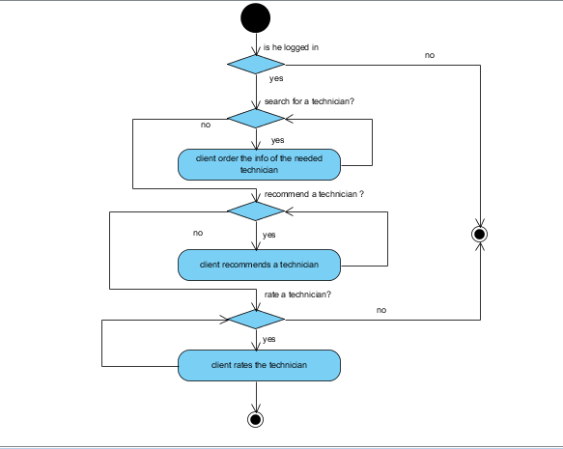

activity diagram of client area module

4.2 Technician Area Module

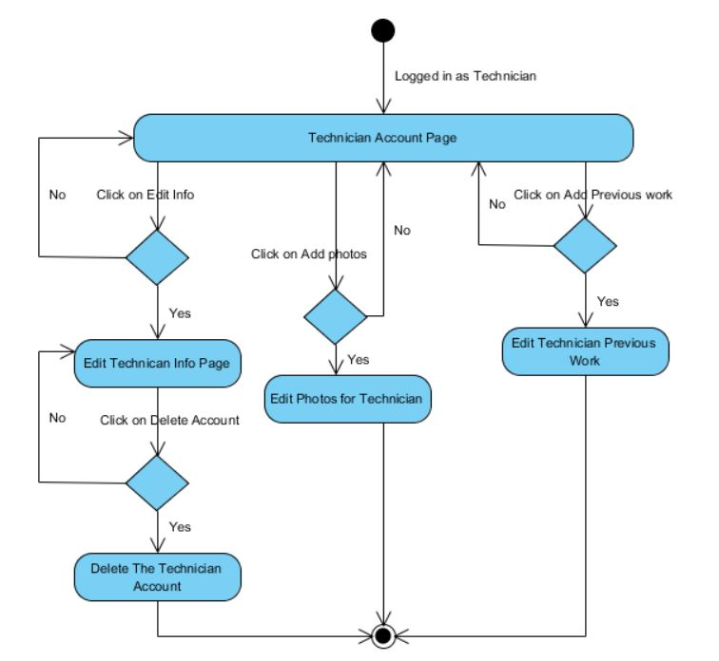This module makes the technician able to edit and enter his information like name, email, mobile phone, job description, photo, address of his workshop, available days &hours during the week and his vacations. In addition to adding photos and add his previous work.

activity diagram of Technician area module

4.3 Data Storage and Processing Module

This module is responsible for all the data processing happening in the website, the data storage including the sending and the receiving of the data related to the technicians and the clients to and from the database of the TechFix website.

4.4 Registration Module

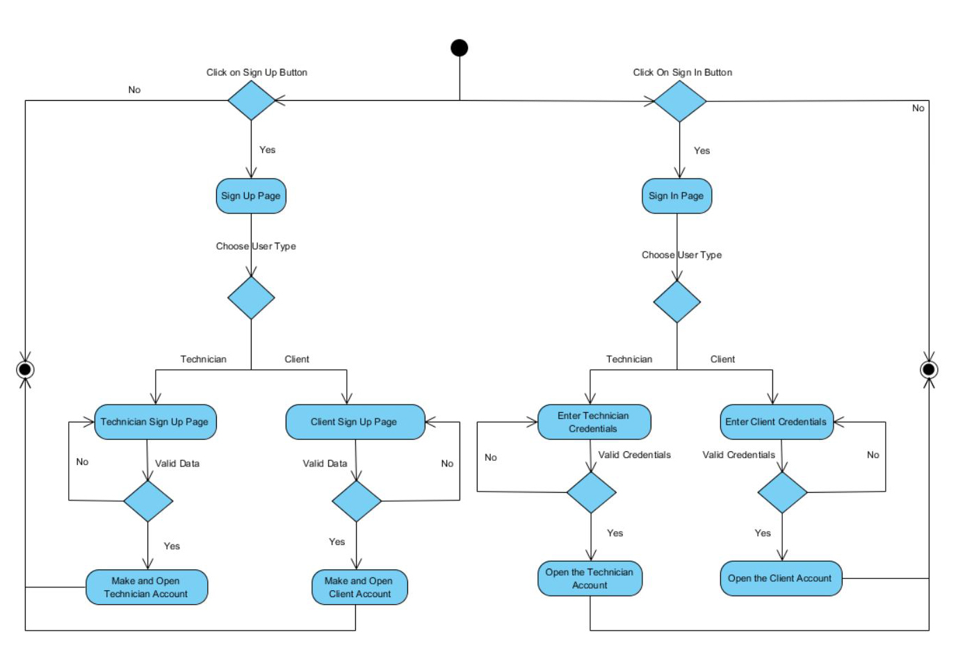This module is responsible for the registration process in the website and the validation of the credentials, whether these credentials are for technicians or clients. This module is responsible for signing up or signing in of different account and account types.

activity diagram of Registration module

**5.0 System Functions**

[FR_CL] Client Area Module

[FR_CL_01] Feedback

|  |  |
| --- | --- |
| Code | FR_CL_01 |
| Description | **This function allows the client to give his/her feedback on a specific**  **Technician on the website** |
| Actors | **Client** |
| Input | **Feedback as text** |
| Output | **--** |
| Pre-conditions | **Already has a client account, The technician account already exists** |
| Post-conditions | **The feedback is visible for all other clients in the future** |

[FR_CL_02] Edit Info

|  |  |
| --- | --- |
| Code | FR_CL_02 |
| Description | **This function allows the client to edit his or her account info (Name, phone number, photo...etc.)** |
| Actors | **Client** |
| Input | **Name**  **Phone Number**  **Photo**  **Email**  **Password** |
| Output | **The outdated info will be overwritten by the new info enterd by the user** |
| Pre-conditions | **Already has a Client Account** |
| Post-conditions | **The new updated info will be visible on the client account** |

[FR_CL_03] Searching

|  |  |
| --- | --- |
| Code | FR_CL_03 |
| Description | **This function allows the client to search for a specific technician** |
| Actors | **Client**  **System to retrieve the search results** |
| Input | **Technician Name**  **Area**  **Category** |
| Output | **The search results** |
| Pre-conditions | **Already has a Client account, Valid input in search** |
| post-conditions | **--** |

[FR_CL_04] Delete Account

|  |  |
| --- | --- |
| Code | FR_CL_04 |
| Description | **This function allows the client to delete his/her account** |
| Input | **--** |
| Output | **Message indicating that the account is deleted** |
| Pre-conditions | **Already has a Client account** |
| post-conditions | **--** |

**[FR_TE]Technician Area Module**

[FR_TE_01] Technician Profile Editing Function

|  |  |
| --- | --- |
| Code | FR_TE_01 |
| Description | **This function allows the technician to edit his/her account** |
| Input | **--** |
| Output | **Message indicating that the account is edited** |
| Pre-conditions | **Already has a technician account** |
| post-conditions | **--** |

[FR_TE_02] Add introduction video function

|  |  |
| --- | --- |
| Code | FR_TE_02 |
| Description | **This function allows the technician to add introduction video to his/her account** |
| Input | **--** |
| Output | **Message indicating that the video is added** |
| Pre-conditions | **Already has a technician account** |
| post-conditions | **--** |

[FR_TE_03] Delete account function

|  |  |
| --- | --- |
| Code | FR_TE_03 |
| Description | **This function allows the technician to delete his/her account** |
| Input | **--** |
| Output | **Message indicating that the account is deleted** |
| Pre-conditions | **Already has a technician account** |
| post-conditions | **--** |

[FR_TE_04] Add previous works

|  |  |
| --- | --- |
| Code | FR_TE_04 |
| Description | **This function allows the technician to add his/her previous works** |
| Input | **Previous works** |
| Output | **Message indicating that the works are added** |
| Pre-conditions | **Already has a technician account** |
| post-conditions | **Previous works are added to his/her account** |

**[FR_RE]Registration Area Module**

[FR_RE_01] Client sign in Function

|  |  |
| --- | --- |
| Code | FR_RE_01 |
| Description | **This function allows the client to sign in to the website** |
| Input | **Email**  **Password** |
| Output | **Message indicating that sign in is successful** |
| Pre-conditions | **--** |
| post-conditions | **Client moves to homepage** |

[FR_RE_02] Technician sign in Function

|  |  |
| --- | --- |
| Code | FR_RE_02 |
| Description | **This function allows the technician to sign in to the website** |
| Input | **Email**  **Password** |
| Output | **Message indicating that sign in is successful** |
| Pre-conditions | **--** |
| post-conditions | **Technician moves to his/her profile** |

[FR_RE_03] Client sign up Function

|  |  |
| --- | --- |
| Code | FR_RE_03 |
| Description | **This function allows the client to sign up to the website** |
| Input | **Name**  **Phone Number**  **Photo**  **Email**  **Password** |
| Output | **Message indicating that sign up is successful** |
| Pre-conditions | **--** |
| post-conditions | **Client moves to homepage** |

[FR_RE_04] Technician sign up Function

|  |  |
| --- | --- |
| Code | FR_RE_04 |
| Description | **This function allows the technician to sign up to the website** |
| Input | **Name**  **Phone Number**  **Photo**  **Email**  **Password**  **Address**  **Available working hours** |
| Output | **Message indicating that sign up is successful** |
| Pre-conditions | **--** |
| post-conditions | **Technicians moves to his/her profile** |

[FR_RE_05] Client\Technician sign out Function

|  |  |
| --- | --- |
| Code | FR_RE_05 |
| Description | **This function allows the client\technician to sign out of the website** |
| Input | **--** |
| Output | **Message indicating that sign out is successful** |
| Pre-conditions | **--** |
| post-conditions | **Client\Technician moves to homepage** |

**5.0 System Models**

5.1 Use case diagrams  
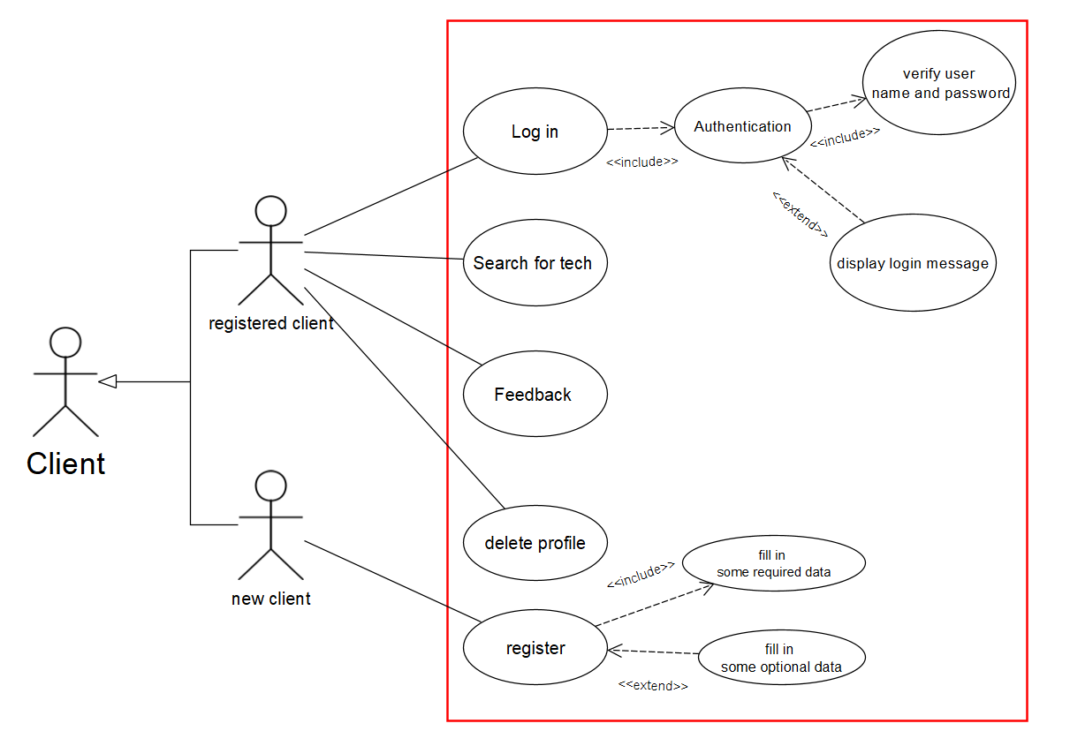

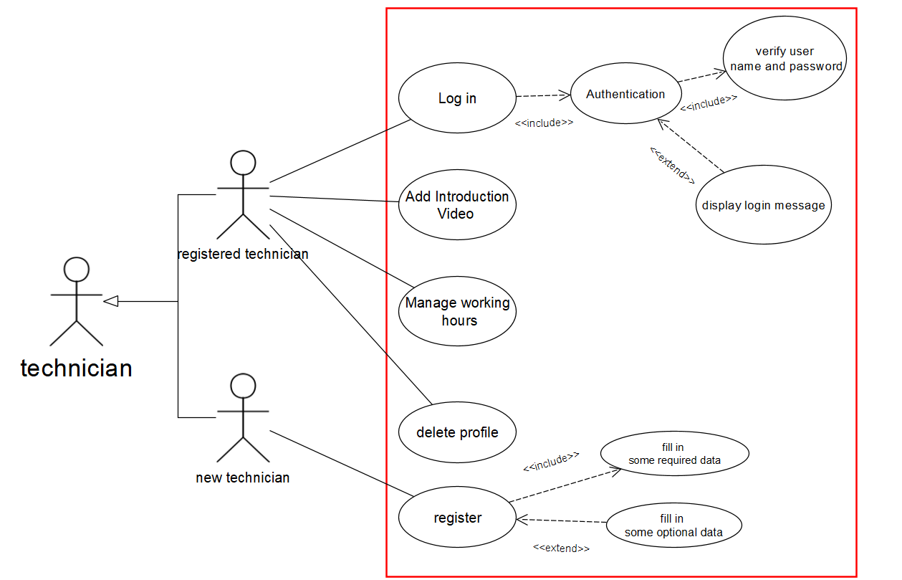

5.2 Sequence Diagram

**6.0 Non-Functional requirements**

[NFR_SE] Security requirement

The system is secured as all the data is well-preserved and can’t be edited by anyone except the owner himself\herself or the administrator.

[NFR_PE] Performance requirement

The system performance is reliable and the response time for transactions is less than 40 sec.

[NFR_DE] Dependability requirement

The system is well served and can’t fail more than 4 times in a year. We also do maintenance to check for unpredictable errors over time.